**Requirement:** Create Dynamic interactive Dashboard for management which updates on daily basis

Sample Dashboard for Analysis as below:

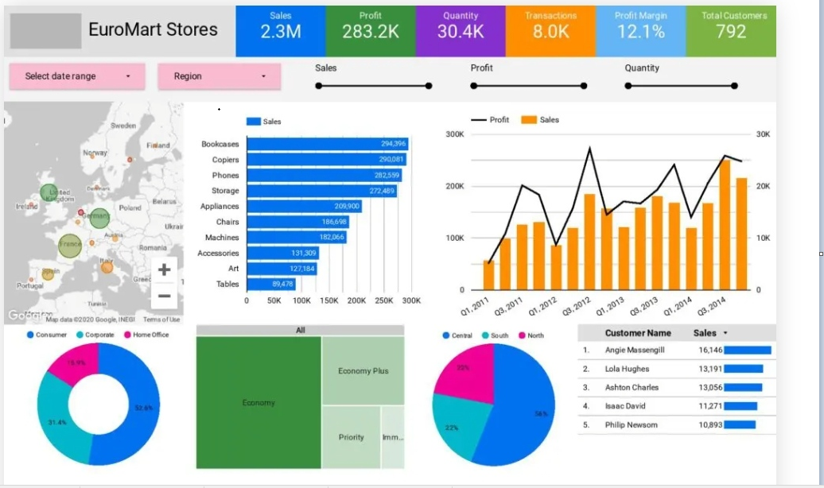

**Data set:** Excel sheet: DMart Data Store.xlsx

Technology to be used:

1. Excel 🡪 Raw Excel received from Operations team
2. Python 🡪 Install Python 3.x on system use it for reading excel and dump data into MS SQL table using Insert Stored Procedure (use libraries required for Excel reading Pandas, SQL pyODBC query use, etc.

Pandas, sys, csv, os, openpyxl, pyodbc, datetime, numpy)

1. MS SQL 🡪 Install MS Sql Express on your laptop and create Table similar to Excel sheet

Create 1. Insert stored procedure 2. Get all details stored procedure

1. Power BI 🡪 Install Power BI desktop on your Laptop and consume Get Stored procedure to fetch dataset from MS SQL DB

We receive Daily excel in same format from operations team and we want to create Dynamic dashboard for the management to analyse and make decisions for sales improvement

Steps to complete the task:

1. Create Database with Table structure similar to Excel data set.
2. Create Insert Procedure to dump data into SQL table using python script – sp_InsertSalesData
3. Create Get Procedure to fetch complete data set into Power BI tool as data set for visualisation – sp_GetSalesData
4. Consume Stored procedure sp_GetSalesData in Power BI and create dashboard similar to above image or best possible analysis according to you.s